Prelab 2

Shiyu Wang

*Pre 2.1) Printing the value of variables using printf statements is one simple debugging approach. However, it is inefficient. Describe how and why it is inefficient.*

Printing the value of variables is Ad-Hoc. Although it has advantages that no special debugging tools needed, it requires intimate knowledge of code and expected values. Also it needs frequent re-compile and execute cycles. Moreover, inserted code can be buggy.

*Pre 2.2) Define in your own words (or as guided by the textbook) what is a debugger?*

A debugger is a program or tool used to test and debug other programs. Breakpoints and single-stepping are common method that used by debugger.

*Pre 2.3) What is the gcc compiler flag for enabling debug symbols?*

gcc -g to compile with debugging flags, for use with gdb.

*Pre 2.4) What is the difference between a syntax error and a programming bug?*

A syntax error is usually easy to find and fix, such as input code is not legal, or errors caught by compiler and other translation mechanism.

A programming bug is an error, flaw, failure or fault in a program that causes it to produce an incorrect or unexpected result. This is usually hard to find or fix. So we often use debugger to help us find them.

Pre 2.5) Compile sieve.c program and execute with entering 25

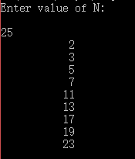

Modify the program to include a print statement in the end

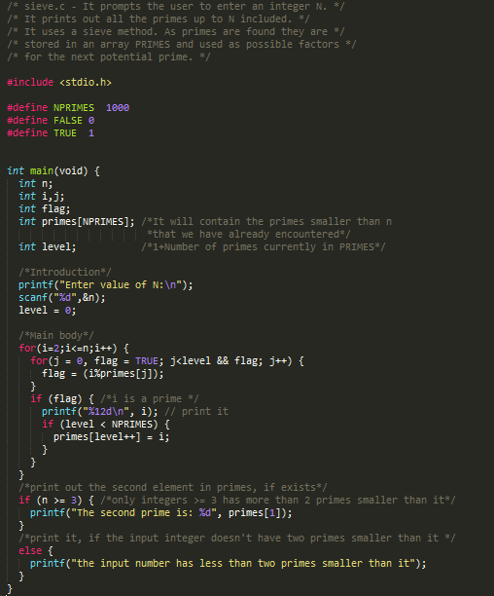

Output:

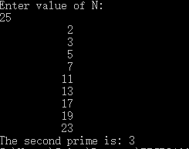

Pre 2.6) The code has an error because of



During this loop, The j can be 0 in the beginning, which is i / 0, so it gives an error.